**2nd Assignment:**

**Submitted By: Sushant Thakur (081BEL092)**

Lottery System In Python

Write a Python program to:

1. Generate a list of 15 random numbers
2. Divide the list into 3 separate lists, each containing 5 elements.
3. Calculate the sum of elements in each of the three lists.
4. Display which list has the greatest sum along with its sum.

**Code:**

import random

main_list = []

for i in range(1, 16):

    main_list.append(random.randint(1, 100))

list_1 = main_list[0:5]

list_2 = main_list[5:10]

list_3 = main_list[10:15]

list_1_sum = sum(list_1)

list_2_sum = sum(list_2)

list_3_sum = sum(list_3)

print("Main list =", main_list)

print("List 1 =", list_1, "Sum =", list_1_sum)

print("List 2 =", list_2, "Sum =", list_2_sum)

print("List 3 =", list_3, "Sum =", list_3_sum)

highest = max(list_1_sum, list_2_sum, list_3_sum)

print("Highest =", highest)

if (highest == list_1_sum):

    print("List 1 has the highest sum")

elif (highest == list_2_sum):

    print("List 2 has the highest sum")

else:

    print("List 3 has the highest sum")

**OUTPUT**:

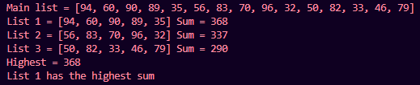

**GitHub Link:**   
https://github.com/SushanThakur/2nd-sem-assignment.git